Employee Attrition Analysis and Prediction Using Machine Learning

A Dissertation
Submitted by

Amruta Kumbar
(AA.SC.P2MCA24074031)
in partial fulfilment of the requirements for the award of the degree of
MASTER OF COMPUTER APPLICATIONS



July 2026


BONAFIDE CERTIFICATE

This is to certify that this dissertation titled " Employee Attrition Analysis and Prediction Using Machine Learning" submitted in partial fulfilment of the requirements for the award of the Degree of Master of Computer Applications, by Amruta Kumbar (Roll No. AA.SC.P2MCA24074031), is a bona fide record of the work carried out by him/her under my supervision during the academic term from April 2026 to August 2026 and that it has been submitted, to the best of my knowledge, in part or in full, for the award of any other degree or diploma.

Athira S Amrita Sindhu M

Reviewer

Date: 24/07/2026

DECLARATION

I do hereby declare that this dissertation titled " Employee Attrition Analysis and Prediction Using Machine Learning", submitted in partial fulfilment of the requirements for the award of the degree of Master of Computer Applications, is a true record of work carried out by me and that all information contained herein, which do not arise directly from my work, have been properly acknowledged and cited, using acceptable international standards. Further, I declare that the contents of this thesis have not been submitted, in part or in full, for the award of any other degree or diploma.

i i i i i i i i i i i i i i i i i i i i i i i i i i i i i i i i i i i
i i i i i i i i i i i i i i i i i i i i i i i i i i i I ASK
Date: i i24/07/2026 i i iAmruta Kumbar

Acknowledgement

I would like to express my sincere gratitude to my project guide for their valuable guidance, continuous support, and helpful feedback throughout the development of this major project.
Their technical insights and direction were instrumental in the successful completion of this work. I also wish to thank the project coordinator for their proper management and for providing all the necessary guidelines and academic resources during this semester.
Furthermore, I am deeply thankful to the faculty members of the MCA department and Amrita Vishwa Vidyapeetham for providing the educational platform, resources, and opportunity to undertake and complete this project successfully.

Abstract

Employee attrition is a major challenge for organizations as it increases recruitment and training costs, reduces productivity, and affects overall organizational performance. Predicting employee attrition in advance helps organizations take proactive measures to improve employee retention and workforce management.
This project develops a machine learning-based employee attrition prediction system using the IBM HR Analytics Employee Attrition dataset from Kaggle. The dataset was preprocessed by encoding categorical variables and standardizing numerical features using StandardScaler. Exploratory Data Analysis (EDA) was performed to understand employee characteristics and identify patterns related to attrition.
Three machine learning algorithms—Logistic Regression, Decision Tree, and Random Forest—were implemented and evaluated. Their performance was measured using accuracy, confusion matrix, classification report, and ROC curve. Among the models, Random Forest achieved the highest prediction accuracy and was selected as the final model due to its superior performance.
A Streamlit web application was also developed to provide an interactive interface where users can enter employee information and predict the likelihood of attrition. The proposed system assists Human Resource professionals in identifying employees who may leave the organization, enabling timely interventions and data-driven decision-making. This approach can help improve employee retention, reduce turnover costs, and support effective human resource management.
Keywords: Employee Attrition, Machine Learning, Random Forest, Decision Tree, Logistic Regression, Human Resource Analytics, Streamlit, Predictive Analytics.

List of Figures
Figure No. | Figure Name
Figure 3.1 | System Architecture
Figure 3.2 | Flowchart
Figure 3.3 | Use Case Diagram
Figure 4.1 | Dataset Overview
Figure 4.2 | Missing Value Analysis
Figure 4.3 | Correlation Heatmap
Figure 4.4 | Age Distribution
Figure 4.5 | Department Distribution
Figure 4.6 | Job Role Distribution
Figure 4.7 | Overtime Analysis
Figure 5.1 | Logistic Regression Results
Figure 5.2 | Decision Tree Results
Figure 5.3 | Random Forest Results
Figure 5.4 | ROC Curve
Figure 5.5 | Streamlit Prediction Interface

List of Tables
Table No. | Table Name
Table 2.1 | Literature Survey
Table 3.1 | Software Requirements
Table 3.2 | Hardware Requirements
Table 4.1 | Dataset Description
Table 4.2 | Data Preprocessing Steps
Table 5.1 | Model Accuracy Comparison
Table 5.2 | Classification Metrics

List of Abbreviations
Abbreviation | Full Form
AI | Artificial Intelligence
ML | Machine Learning
HR | Human Resources
EDA | Exploratory Data Analysis
RF | Random Forest
DT | Decision Tree
LR | Logistic Regression
ROC | Receiver Operating Characteristic
AUC | Area Under Curve
CSV | Comma Separated Values
GUI | Graphical User Interface
API | Application Programming Interface

Chapter 1

1.1 Introduction
Employee attrition is a major challenge for organizations as it increases recruitment costs, training efforts, and productivity loss. Machine learning enables organizations to predict employee attrition by analyzing historical HR data such as job role, salary, work experience, overtime, and job satisfaction. This project develops an employee attrition prediction system using the IBM HR Analytics dataset and implements a Streamlit web application to support HR professionals in making data-driven decisions.
1.2 Background and Motivation
Employee turnover affects organizational performance and increases operational costs. Predicting attrition in advance helps organizations retain valuable employees and improve workforce planning. This project demonstrates the application of machine learning in HR analytics while providing practical experience in data analysis, model development, and web application deployment.
1.3 Problem Statement
Organizations often identify employee attrition only after employees decide to leave, leading to higher costs and reduced productivity. This project aims to develop a machine learning model that predicts employee attrition in advance, enabling HR teams to take timely retention measures.
1.4 Objectives
- Study the IBM HR Analytics dataset.
- Preprocess and analyze employee data.
- Develop prediction models using Logistic Regression, Decision Tree, and Random Forest.
- Compare model performance.
- Build a Streamlit application for employee attrition prediction.
1.5 Scope of the Project
The project focuses on predicting employee attrition using historical HR data. It includes data preprocessing, model development, evaluation, and deployment through a Streamlit application. It is designed as a decision-support tool and does not integrate with live HR systems.
1.6 Tools and Technologies Used
Software: Python 3.12, Jupyter Notebook/Google Colab, Streamlit, VS Code, Microsoft Word.
Libraries: Pandas, NumPy, Matplotlib, Seaborn, Scikit-learn, Joblib.
Dataset: IBM HR Analytics Employee Attrition Dataset (Kaggle).
1.7 Methodology Overview
The project follows these steps:
- Data Collection
- Data Preprocessing
- Exploratory Data Analysis
- Feature Encoding
- Model Training
- Model Evaluation
- Streamlit Application Development
1.8 Organization of the Report
- Chapter 1: Introduction and project overview.
- Chapter 2: Literature review.
- Chapter 3: System design and methodology.
- Chapter 4: Implementation and model development.
- Chapter 5: Results and performance evaluation.
- Chapter 6: Conclusion and future scope.
- Chapter 7: References.
- Chapter 8: Appendix.
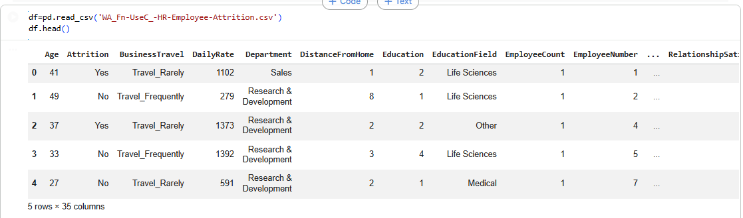

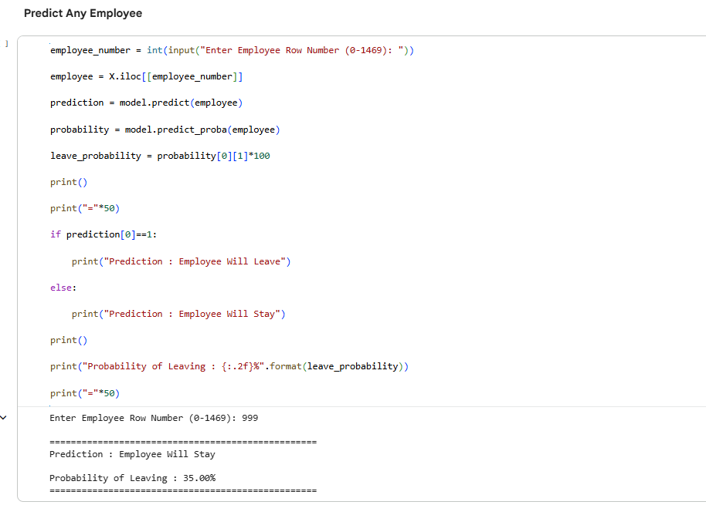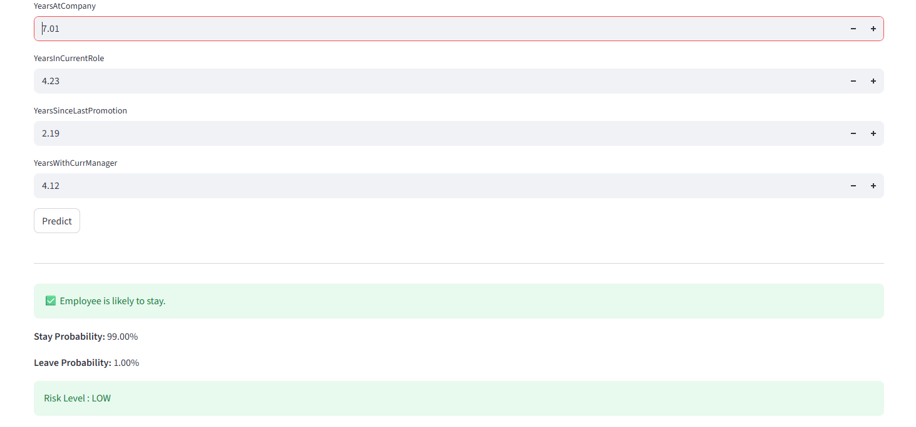
Chapter 2
LITERATURE REVIEW
2.1 Introduction
Employee attrition is a major concern for organizations because it affects productivity, increases recruitment costs, and disrupts business operations. With the growth of Human Resource (HR) Analytics, machine learning has become an effective approach for predicting employee turnover. By analyzing historical employee data, predictive models can identify employees who may leave the organization, enabling HR teams to take preventive actions. This chapter reviews previous studies on employee attrition prediction, highlights commonly used machine learning algorithms, and identifies research gaps addressed by the proposed system.
2.2 Review of Existing Studies
Several researchers have applied machine learning techniques to predict employee attrition. Logistic Regression has been widely used because of its simplicity and ease of interpretation, although its prediction performance may be lower for complex datasets. Decision Tree models are popular for their ability to generate understandable decision rules but are often affected by overfitting.
Random Forest has shown better performance in many studies due to its ensemble learning approach, which improves prediction accuracy and reduces overfitting. Other algorithms, such as Support Vector Machine (SVM), Naïve Bayes, Gradient Boosting, and Artificial Neural Networks, have also been explored for employee attrition prediction. While these methods produce reliable results, some require higher computational resources and are more difficult to interpret.
Most previous research has focused on improving prediction accuracy using the IBM HR Analytics dataset and similar HR datasets. However, only a limited number of studies have developed user-friendly applications that allow HR professionals to use prediction models in real-world environments.
2.3 Comparison of Existing Studies
Study | Algorithm | Key Finding | Limitation
Study 1 | Logistic Regression | Simple and interpretable model | Moderate accuracy
Study 2 | Decision Tree | Easy visualization and classification | Overfitting
Study 3 | Random Forest | High prediction accuracy | Higher computational cost
Study 4 | SVM | Good classification performance | Complex implementation
Proposed System | Random Forest | High accuracy with Streamlit deployment | Decision-support system only
2.4 Research Gap
Existing studies mainly concentrate on developing accurate prediction models but provide limited support for practical implementation. Many systems lack interactive interfaces for HR professionals and compare only a few machine learning algorithms. There is a need for a simple, accurate, and user-friendly prediction system that can assist organizations in making data-driven employee retention decisions.
2.5 Proposed Solution
The proposed system predicts employee attrition using the IBM HR Analytics dataset. The project includes data preprocessing, exploratory data analysis, feature encoding, model training, and performance evaluation using multiple machine learning algorithms. Random Forest is selected as the final model based on its performance. A Streamlit web application is developed to provide an interactive interface for predicting employee attrition using employee information.
2.6 Advantages of the Proposed System
- Predicts employee attrition at an early stage.
- Supports data-driven HR decision-making.
- Reduces employee turnover and recruitment costs.
- Compares multiple machine learning algorithms.
- Provides an easy-to-use Streamlit web application.
- Improves workforce planning and retention strategies.
2.7 Chapter Summary
This chapter reviewed previous research on employee attrition prediction using machine learning techniques. Different algorithms, including Logistic Regression, Decision Tree, Random Forest, and SVM, were discussed along with their strengths and limitations. The review identified the need for a practical prediction system with an interactive interface. Based on these findings, the proposed system combines machine learning with a Streamlit application to provide an effective employee attrition prediction solution.
Chapter 3

3.1 Programming Environment and Dataset
This project was developed using Python in a Jupyter Notebook environment. The IBM HR Analytics Employee Attrition dataset obtained from Kaggle was used for building the prediction system. The dataset contains employee information such as age, education, department, monthly income, job role, work experience, overtime, job satisfaction, and attrition status.
Before training the machine learning models, the dataset was examined to understand its structure, data types, and quality. The dataset was checked for missing values, duplicate records, and inconsistencies to ensure reliable model performance.

3.2 Data Preprocessing
The raw dataset cannot be used directly for machine learning. Therefore, several preprocessing steps were performed to prepare the data.
The preprocessing process included:
- Loading the dataset
- Checking missing values
- Removing duplicate records
- Encoding categorical variables using Label Encoder
- Splitting features and target variable
- Standardizing numerical features using StandardScaler
These steps ensured that the dataset was suitable for training machine learning algorithms.

3.3 Exploratory Data Analysis (EDA)
Exploratory Data Analysis was carried out to understand the characteristics of the employee dataset and identify factors related to employee attrition.
Several visualizations were created using Matplotlib and Seaborn to analyze important employee attributes. These visualizations helped identify trends and relationships between different variables.
The analysis included:
- Employee Attrition Distribution
- Department-wise Employees
- Gender Distribution
- Age Distribution
- Monthly Income Distribution
- Overtime Analysis
- Job Satisfaction Analysis
- Correlation Heatmap
These insights helped in selecting relevant features for prediction. 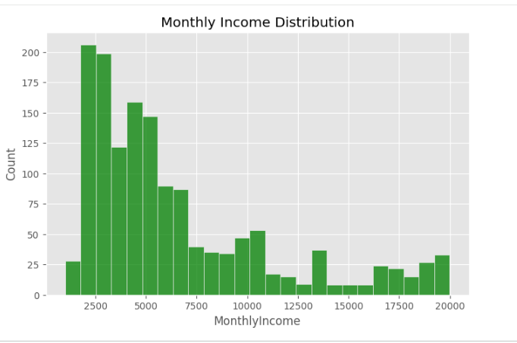
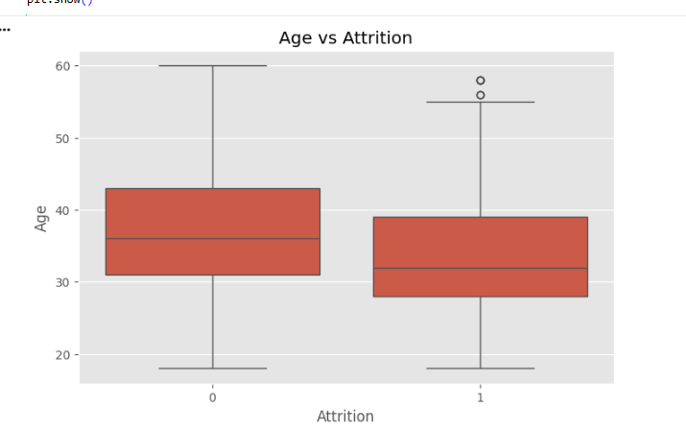
3.4 Machine Learning Model Development
After preprocessing the dataset, three supervised machine learning algorithms were implemented to predict employee attrition.
The models used are:
- Logistic Regression
- Decision Tree Classifier
- Random Forest Classifier
The dataset was divided into training and testing sets. Each model was trained using the training data and evaluated using the testing data.
The Random Forest model achieved the highest prediction accuracy and was selected as the final model.
i
3.5 Model Evaluation
The performance of each machine learning model was evaluated using different classification metrics.
The evaluation metrics include:
- Accuracy
- Precision
- Recall
- F1-Score
- Confusion Matrix
- Classification Report
- ROC Curve
After comparing all three models, Random Forest provided the most accurate and reliable predictions.

3.6 Streamlit Application
After selecting the best-performing model, it was saved using the Joblib library and integrated into a Streamlit web application.
The application allows users to enter employee information through an interactive interface and instantly predicts whether the employee is likely to leave the organization.
The application provides a simple and user-friendly way for HR professionals to use the prediction model without requiring programming knowledge.

3.7 System Workflow
The overall workflow of the project is shown below:
Dataset Collection
↓
Data Preprocessing
↓
Exploratory Data Analysis
↓
Feature Encoding
↓
Feature Scaling
↓
Train-Test Split
↓
Machine Learning Model Training
↓
Model Evaluation
↓
Select Best Model
↓
Deploy using Streamlit
↓
Employee Attrition Prediction

3.8 Chapter Summary
This chapter explained the methodology adopted for developing the Employee Attrition Prediction System. It described the programming environment, data preprocessing techniques, exploratory data analysis, machine learning model development, model evaluation, and deployment using Streamlit. The next chapter presents the implementation process with code snippets, screenshots, and experimental results.

Chapter 4
IMPLEMENTATION DETAILS
4.1 Introduction
This chapter explains the implementation of the Employee Attrition Prediction System. It describes the steps involved in data preprocessing, exploratory data analysis, machine learning model development, model evaluation, and deployment using a Streamlit web application. The project was implemented in Python using Jupyter Notebook, with Scikit-learn for machine learning and Streamlit for the user interface.

4.2 Data Preprocessing Implementation
The first stage of the project involved preparing the dataset for machine learning. The IBM HR Analytics Employee Attrition dataset was loaded using the Pandas library. The dataset was checked for missing values, duplicate records, and incorrect data types.
Categorical attributes such as Gender, Department, Job Role, Marital Status, Overtime, and Business Travel were converted into numerical values using Label Encoding. Numerical features were standardized using StandardScaler to improve model performance.
Pseudo-code
Load dataset
Check missing values
Remove duplicate records
Encode categorical variables
Separate features and target
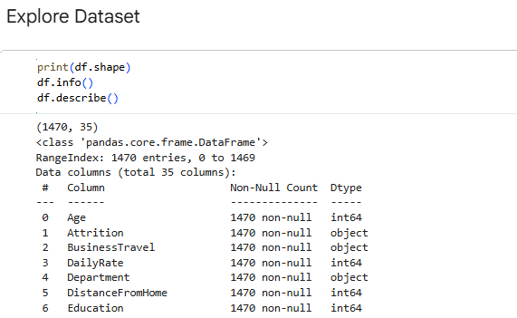
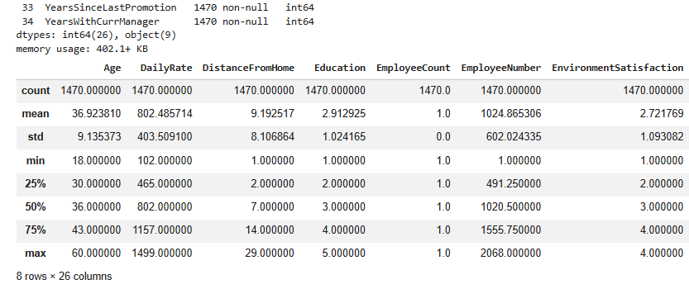
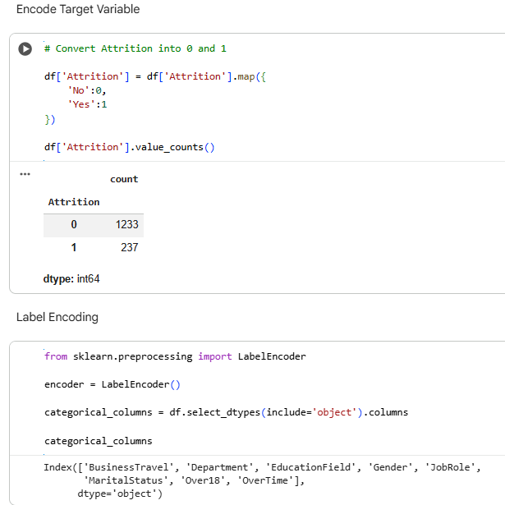
4.3 Exploratory Data Analysis Implementation
Exploratory Data Analysis (EDA) was performed to understand employee characteristics and identify factors affecting employee attrition. Various visualizations were created using Matplotlib and Seaborn.
The analysis included employee age distribution, department distribution, monthly income, overtime, job satisfaction, work-life balance, and correlation among features. These visualizations helped identify the important variables used during model training.
Pseudo-code
Load processed dataset
Generate statistical summary
Create distribution plots
Generate count plots
Plot correlation heatmap
Analyze feature relationships
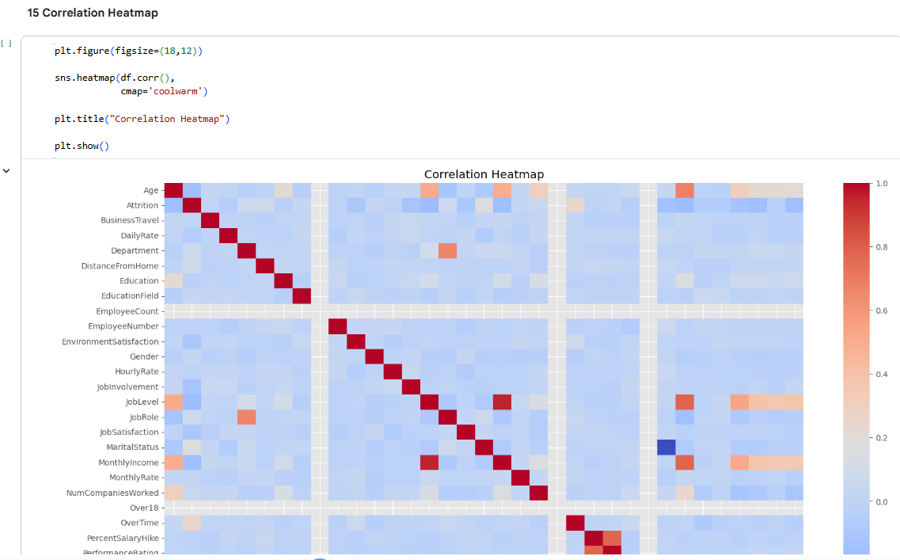
4.4 Machine Learning Model Implementation
The processed dataset was divided into training and testing datasets using the Train-Test Split technique. Three supervised machine learning algorithms were implemented.
- Logistic Regression
- Decision Tree Classifier
- Random Forest Classifier
Each model was trained using the training dataset and tested on unseen employee records. The trained models were then compared based on their prediction performance.
Pseudo-code
Split dataset into train and test sets
Train Logistic Regression model
Train Decision Tree model
Train Random Forest model
Generate predictions
Compare model performance
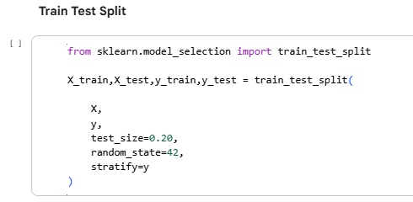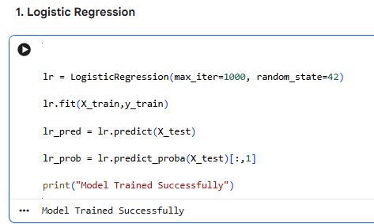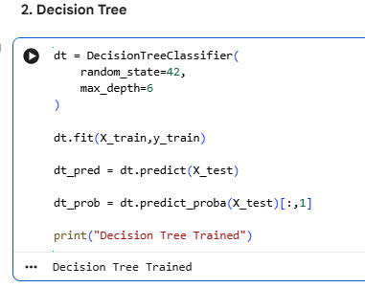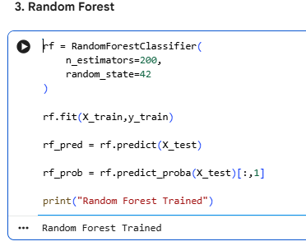
4.5 Model Testing and Evaluation
The trained models were evaluated using different classification metrics to determine the best-performing algorithm.
The evaluation metrics include:
- Accuracy
- Precision
- Recall
- F1-Score
- Confusion Matrix
- Classification Report
- ROC Curve
Among all the models, Random Forest produced the highest prediction accuracy and was selected for deployment.
Pseudo-code
Predict test data
Calculate accuracy
Generate confusion matrix
Generate classification report
Plot ROC curve
Compare Models
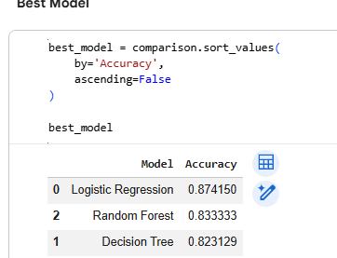
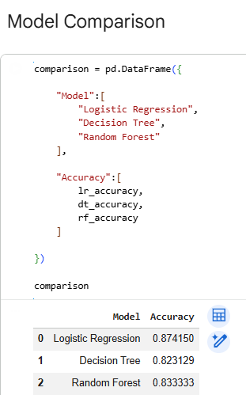
4.6 Streamlit Application Implementation
The trained Random Forest model was saved using the Joblib library and integrated into a Streamlit web application.
The application allows users to enter employee information such as age, monthly income, job role, overtime, and job satisfaction. After clicking the prediction button, the application displays whether the employee is likely to stay or leave the organization.
The Streamlit interface provides a simple and user-friendly platform for HR professionals without requiring programming knowledge.
Pseudo-code
Load trained model
Accept employee input
Preprocess input values
Predict attrition
Display prediction result
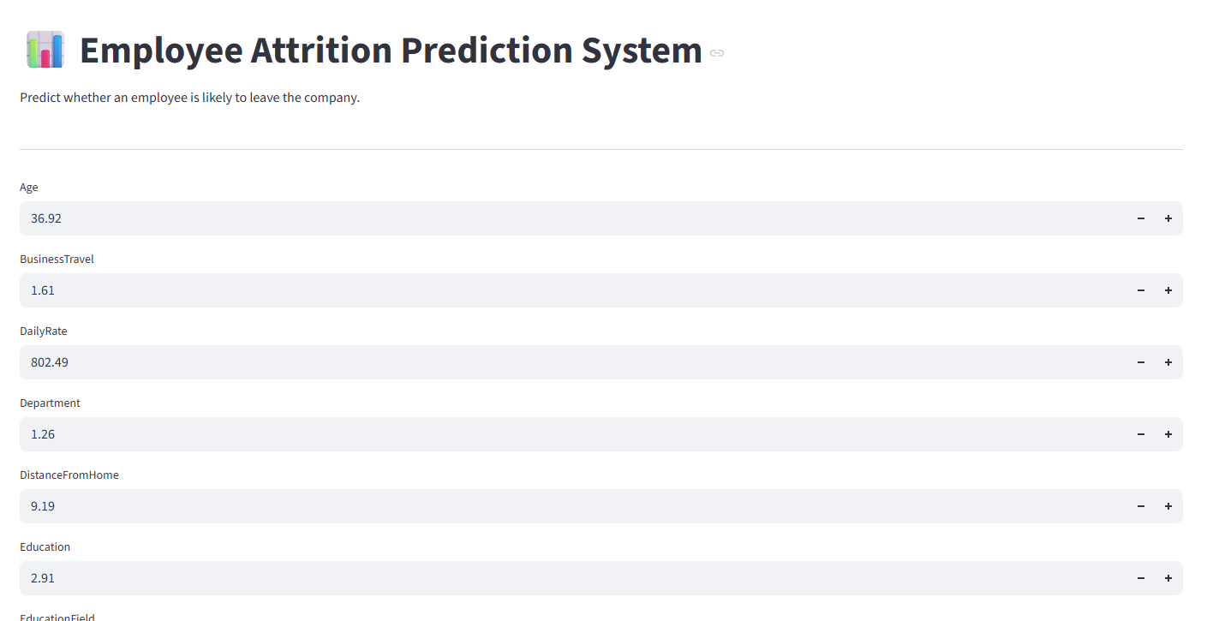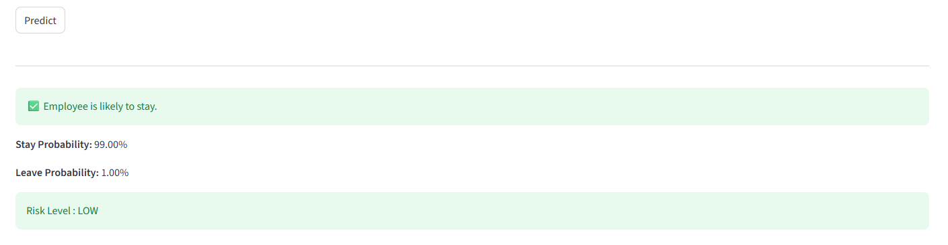
4.7 Integration Process
The project integrates multiple software components into a single prediction system. The dataset is processed using Pandas and NumPy, visualized using Matplotlib and Seaborn, and modeled using Scikit-learn. The final Random Forest model is saved using Joblib and loaded into a Streamlit application for real-time predictions.
The integration ensures that user inputs are processed using the same preprocessing steps as the training data before generating predictions.

4.8 Chapter Summary
This chapter presented the implementation details of the Employee Attrition Prediction System. It explained data preprocessing, exploratory data analysis, machine learning model development, testing, evaluation, deployment, and software integration. The implementation demonstrates how machine learning and Streamlit were combined to develop an interactive employee attrition prediction application.
Chapter 5
TESTING, VALIDATION AND RESULTS
5.1 Introduction
Testing and validation are essential to evaluate the performance and reliability of the Employee Attrition Prediction System. This chapter describes the testing process, evaluation metrics, and comparative analysis of the implemented machine learning models. The results help identify the most suitable model for predicting employee attrition.

5.2 Testing Methodology
The dataset was divided into training and testing sets using the Train-Test Split method. The training dataset was used to build the machine learning models, while the testing dataset was used to evaluate their performance on unseen data.
Three classification algorithms were tested:
- Logistic Regression
- Decision Tree
- Random Forest
The predictions generated by each model were compared with the actual employee attrition values to measure their effectiveness.

5.3 Performance Evaluation Metrics
The models were evaluated using the following metrics:
Accuracy
Accuracy measures the percentage of correctly classified employee records.
Formula:
Accuracy = (TP + TN) / (TP + TN + FP + FN)
Precision
Precision indicates how many employees predicted to leave actually left the organization.
Formula:
Precision = TP / (TP + FP)
Recall
Recall measures the ability of the model to correctly identify employees who are likely to leave.
Formula:
Recall = TP / (TP + FN)
F1-Score
F1-Score is the harmonic mean of Precision and Recall and provides a balanced evaluation of the model.
Formula:
F1-Score = 2 × (Precision × Recall) / (Precision + Recall)

5.4 Experimental Results
The performance of the three machine learning models was compared using the testing dataset.
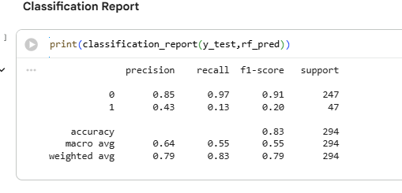Table 5.1: Performance Comparison of Machine Learning Models

5.5 Result Analysis
The evaluation results show that all three algorithms successfully predicted employee attrition, but their performance varied. Logistic Regression provided a simple baseline model, while Decision Tree offered better interpretability. Random Forest achieved the highest overall performance due to its ensemble learning approach, making it more accurate and less prone to overfitting.
Based on the evaluation metrics, Random Forest was selected as the final prediction model and deployed in the Streamlit application.

5.6 Validation
The prediction system was validated using unseen test data to ensure that the trained model generalized well to new employee records. The evaluation metrics and confusion matrix confirmed that the selected model produced reliable predictions suitable for decision-support purposes. 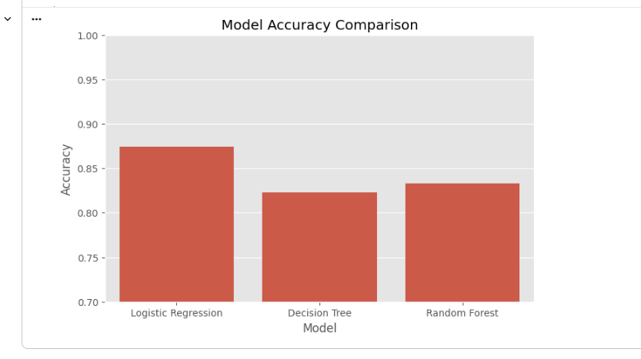
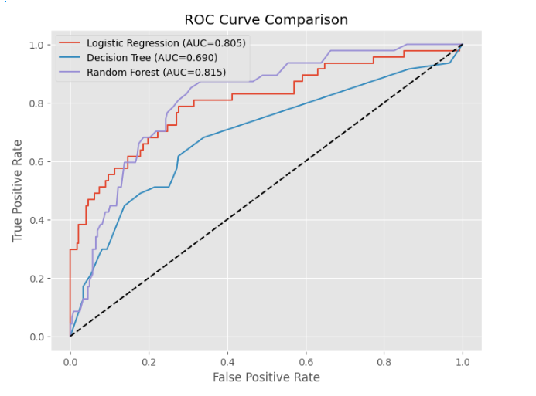
5.7 Chapter Summary
This chapter presented the testing methodology, validation process, and performance analysis of the implemented machine learning models. The models were evaluated using Accuracy, Precision, Recall, F1-Score, Confusion Matrix, and ROC Curve. Among the evaluated models, Random Forest achieved the best performance and was selected for deployment in the Employee Attrition Prediction System.

Chapter 6
CONCLUSION AND FUTURE WORK
6.1 Conclusion
This project presented a machine learning-based Employee Attrition Prediction System using the IBM HR Analytics Employee Attrition dataset. The system was developed to predict whether an employee is likely to leave an organization based on various personal and job-related attributes.
The project involved data preprocessing, exploratory data analysis, model training, evaluation, and deployment through a Streamlit web application. Three machine learning algorithms—Logistic Regression, Decision Tree, and Random Forest—were implemented and compared using standard evaluation metrics. Among them, the Random Forest model achieved the best overall performance and was selected as the final prediction model.
The developed application provides a simple and interactive interface that can assist Human Resource professionals in identifying employees at risk of attrition. The project demonstrates how machine learning can support data-driven decision-making and improve employee retention strategies.

6.2 Contributions
The major contributions of this project are:
- Developed a machine learning model for employee attrition prediction.
- Compared the performance of multiple classification algorithms.
- Built a user-friendly Streamlit web application.
- Demonstrated the practical use of HR analytics for employee retention.

6.3 Limitations
The current system has the following limitations:
- The model is trained only on the IBM HR Analytics dataset.
- Real-time HR database integration is not included.
- Prediction accuracy depends on the quality of the input data.
- The system is intended as a decision-support tool and does not replace human judgment.

6.4 Future Work
The project can be enhanced in several ways:
- Train the model using larger and more diverse HR datasets.
- Evaluate advanced machine learning and deep learning algorithms.
- Integrate the system with real-time HR management platforms.
- Include explainable AI techniques to provide reasons for predictions.
- Deploy the application on a cloud platform for wider accessibility.

6.5 Chapter Summary
This chapter summarized the project, highlighted its contributions and limitations, and suggested possible future enhancements. The developed Employee Attrition Prediction System demonstrates the potential of machine learning in supporting Human Resource analytics and improving employee retention through data-driven insights.

Chapter 7

REFERENCES
[1] IBM, "IBM HR Analytics Employee Attrition & Performance Dataset," Kaggle. [Online]. Available: https://www.kaggle.com/datasets/pavansubhasht/ibm-hr-analytics-attrition-dataset. [Accessed: Jul. 2026].
[2] F. Pedregosa et al., "Scikit-learn: Machine Learning in Python," Journal of Machine Learning Research, vol. 12, pp. 2825–2830, 2011.
[3] W. McKinney, Python for Data Analysis. Sebastopol, CA, USA: O'Reilly Media, 2022.
[4] T. Chen and C. Guestrin, "XGBoost: A Scalable Tree Boosting System," in Proceedings of the 22nd ACM SIGKDD International Conference on Knowledge Discovery and Data Mining, 2016, pp. 785–794.
[5] Streamlit Inc., "Streamlit Documentation." [Online]. Available: https://docs.streamlit.io/. [Accessed: Jul. 2026].
[6] NumPy Developers, "NumPy Documentation." [Online]. Available: https://numpy.org/doc/. [Accessed: Jul. 2026].
[7] Pandas Development Team, "Pandas Documentation." [Online]. Available: https://pandas.pydata.org/docs/. [Accessed: Jul. 2026].
[8] J. D. Hunter, "Matplotlib: A 2D Graphics Environment," Computing in Science & Engineering, vol. 9, no. 3, pp. 90–95, 2007.
[9] M. L. Waskom, "Seaborn: Statistical Data Visualization," Journal of Open Source Software, vol. 6, no. 60, p. 3021, 2021.
[10] Google, "Google Colaboratory Documentation." [Online]. Available: https://colab.research.google.com/. [Accessed: Jul. 2026].

Chapter 8
APPENDIX
This appendix contains supporting materials related to the development and implementation of the Employee Attrition Prediction System. These resources provide additional information beyond the main report.
8.1 GitHub Repository
The complete source code of the project, including the machine learning model, preprocessing scripts, and Streamlit application, is available in the GitHub repository.
GitHub Link:
https://github.com/Amrutakumbar/Employee-Attrition-Prediction_Major_Project.git

8.2 Code Samples
The project includes the following Python modules:
- Dataset loading and preprocessing
- Exploratory Data Analysis (EDA)
- Label Encoding and Feature Scaling
- Machine Learning model training
- Model evaluation
- Streamlit web application
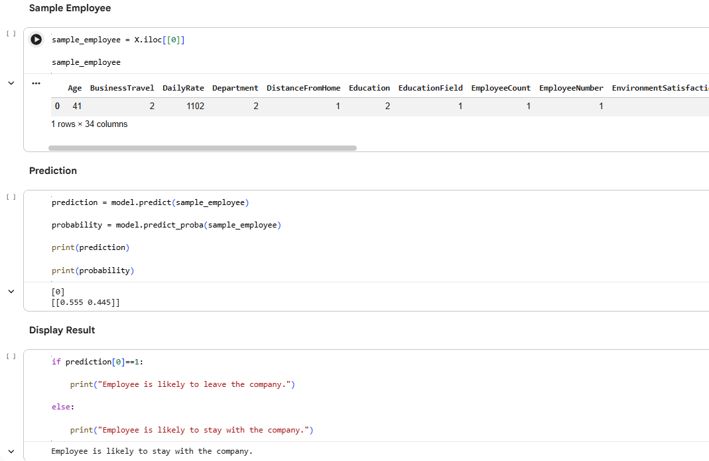

8.3 Dataset Sample
The project uses the IBM HR Analytics Employee Attrition dataset obtained from Kaggle. The dataset contains employee demographic, job-related, and organizational attributes used to train the prediction models.

8.4 Additional Results
Additional outputs generated during the project include:
- Accuracy comparison of machine learning models
- Confusion Matrix
- Classification Report
- ROC Curve
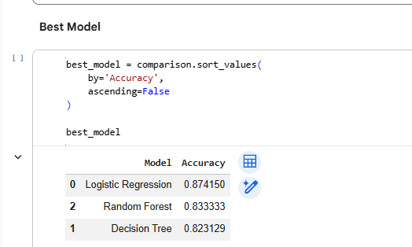
8.5 User Manual
To use the application:
- Open the Streamlit application.
- Enter the required employee details.
- Click the Predict button.
- View the predicted employee attrition result.
The application provides a simple interface for HR professionals to estimate whether an employee is likely to stay or leave the organization.
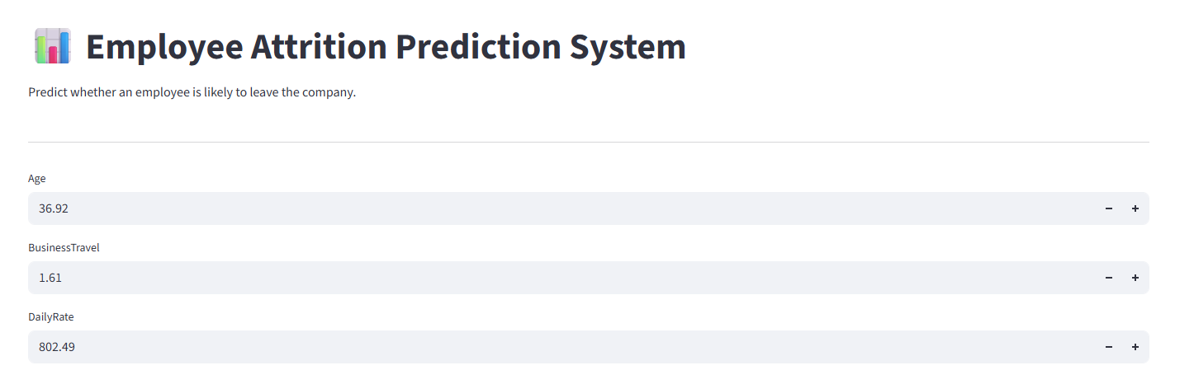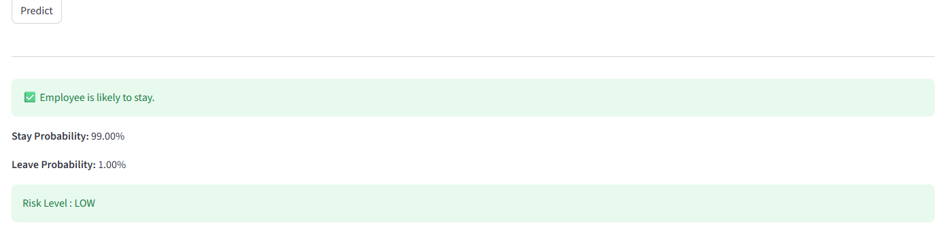

Date 24/07/2026
Student Name and Signature :
Amruta Kumbar i
ASK

Name and Signature of the Evaluator.

Date

